Course 5



Cluster 0: These students display the most Moodle activity, but either most of them did not YET complete the course requirements in order to receive a final course grade, or their final course grade wasn’t recorded in Moodle.

Cluster 1: These students displayed the least Moodle and most of them failed the course.

Cluster 2: These students display the 2nd most Moodle activity and most of them passed the course.

General Interpretation:

* This data set have the least attributes with missing values.
* Missing values for forum read and quiz failed count.

Course 12



Cluster 0: These students’ Moodle activities had the median values. Despite utilizing Moodle more than cluster 1, most of these students failed the course. They supplemented their lower quiz count with their Forum Read activity, yet they failed all their quizzes.

Cluster 1: These are the students with the lowest Moodle activity, but either most of them did not YET complete the course requirements in order to receive a final course grade, or their final course grade wasn’t recorded in Moodle. They also supplemented their lower quiz count with their Forum Read activity, yet they failed all their quizzes.

Cluster 3: These students display the most Moodle activity. Although they didn’t need much Forum Read activity because they completed the most quizes, their effort on the may have caused them to have the most Forum Post in consideration of the opposite conditions of cluster 1 and 0. Despite their effort they also failed all of their quizzes.

General Interpretation:

* The utilization of Moodle in this course has some weight on the success of students.
* Student clusters with lower quiz counts tend to supplement this with higher Forum Read activity and students with higher quiz counts tend to have higher Forum Post activity.
* All students failed every quiz.
* Missing values for assignment count, assignment time, and quiz passed count.

Course 4

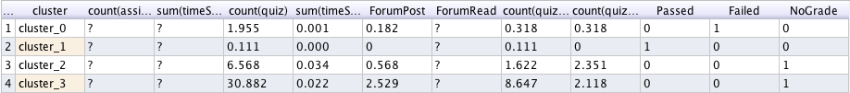

Cluster 0: These students display more Moodle activity than cluster 1, but most of them failed the course.

Cluster 1: Despite these students displaying the least Moodle activity (less than cluster 0) most of them passed the course.

Cluster 2: These students display the 2nd most Moodle activity, but either most of them did not YET complete the course requirements in order to receive a final course grade, or their final course grade wasn’t recorded in Moodle.

Cluster 3: These students display the most Moodle activity, but either most of them did not YET complete the course requirements in order to receive a final course grade, or their final course grade wasn’t recorded in Moodle.

General Interpretation:

* The discrepancy between cluster 0 student failure and cluster 1 student success leads to the conclusion that Moodle’s role did not adequately supplement students’ education for this course.
* Missing values for assignment count, assignment time, and forum read.

Course 15



Cluster 0: These students with the most forum post activity passed the course.

Cluster 1: Despite these students having the highest quiz count, they have less forum post activity than cluster 0 which may have resulted in their overall failure of the course.

Cluster 3: Either most of them did not YET complete the course requirements in order to receive a final course grade, or their final course grade wasn’t recorded in Moodle.

General Interpretation:

* Student clusters more active with Forum Posts tend to pass the course
* Missing values for assignment count, assignment time, and quiz passed count.

Course 3:

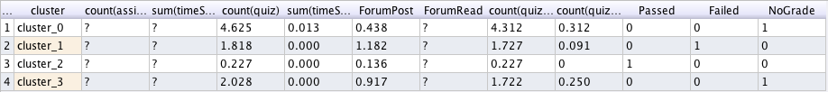

Cluster 0: These students display the most overall Moodle activity, but either most of them did not YET complete the course requirements in order to receive a final course grade, or their final course grade wasn’t recorded in Moodle.

Cluster 1: These students display more Moodle activity than cluster 2, but most of them failed the course.

Cluster 2: Despite these students displaying the least Moodle activity (less than cluster 1) most of them passed the course.

Cluster 3: These students display the 2nd most overall Moodle activity, but either most of them did not YET complete the course requirements in order to receive a final course grade, or their final course grade wasn’t recorded in Moodle.

General Interpretation:

* The discrepancy between cluster 1 student failure and cluster 2 student success leads to the conclusion that Moodle’s role did not adequately supplement students’ education for this course.
* Missing values for assignment count, assignment time, and forum read.